**Name : Khushi Nitinkumar Patel**

**PRN : 2020BTECS00037**

**EXPERIMENT NO 11**

**Title of experiment :** WAP for arranging numbers in ascending and descending order.

**Equipment required :** GNU Simulator.

**Theory :**

**For ascending order :**

1) Initialize HL pair as memory pointer.

2)Get the count at 4200 in to C register.

3)Copy it in D register.

4)Get the first vale in Accumulator.

5)Compare it with the value at next location.

6)If they are out of order, exchange the contents of accumulator and memory.

7)Decrement D register’s content by 1.

8)Repeat steps 5 and 7 till the value in D register become zero.

9)Decrement C register’s content by 1.

10)Repeat steps 3 to 9 till the value in C register becomes zero.

11)Terminate the program.

**For descending :**

1)Initialize HL pair as memory pointer.

2)Get the count at 4200 in to C register.

3)Copy it in D register.

4)Get the first vale in Accumulator.

5)Compare it with the value at next location.

6)If they are out of order, exchange the contents of accumulator and memory.

7)Decrement D register’s content by 1.

8)Repeat steps 5 and 7 till the value in D register become zero.

9)Decrement C register’s content by 1.

10)Repeat steps 3 to 9 till the value in C register becomes zero.

11)Terminate the program.

**Program code :**

**;Arrange in ascending order**

LDA 1100

MOV B,A

DCR B

LOOP3: LXI H,1100

MOV C,M

DCR C

INX H

LOOP2: MOV A,M

INX H

CMP M

JC LOOP1

MOV D,M

MOV M,A

DCX H

MOV M,D

INX H

LOOP1: DCR C

JNZ LOOP2

DCR B

JNZ LOOP3

HLT

**;Arrange in descending order**

LDA 1100

MOV B,A

DCR B

LOOP3: LXI H,1100

MOV C,M

DCR C

INX H

LOOP2: MOV A,M

INX H

CMP M

JNC LOOP1

MOV D,M

MOV M,A

DCX H

MOV M,D

INX H

LOOP1: DCR C

JNZ LOOP2

DCR B

JNZ LOOP3

HLT

**Snap shots :**

**Arrange in ascending order :**

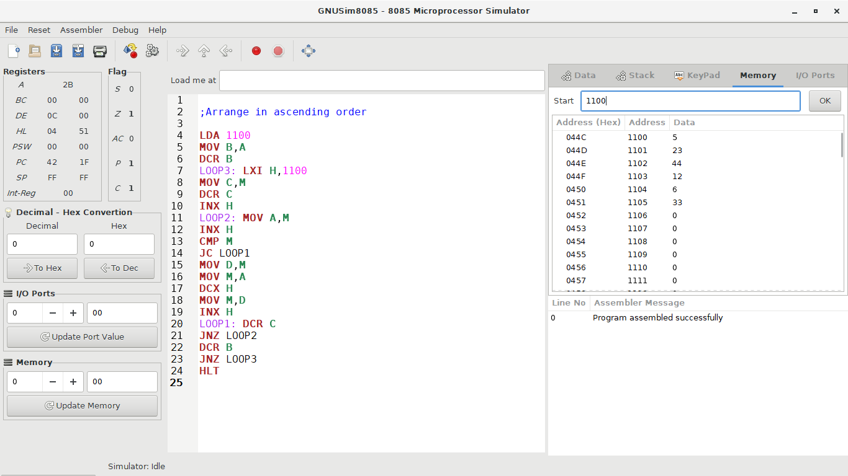

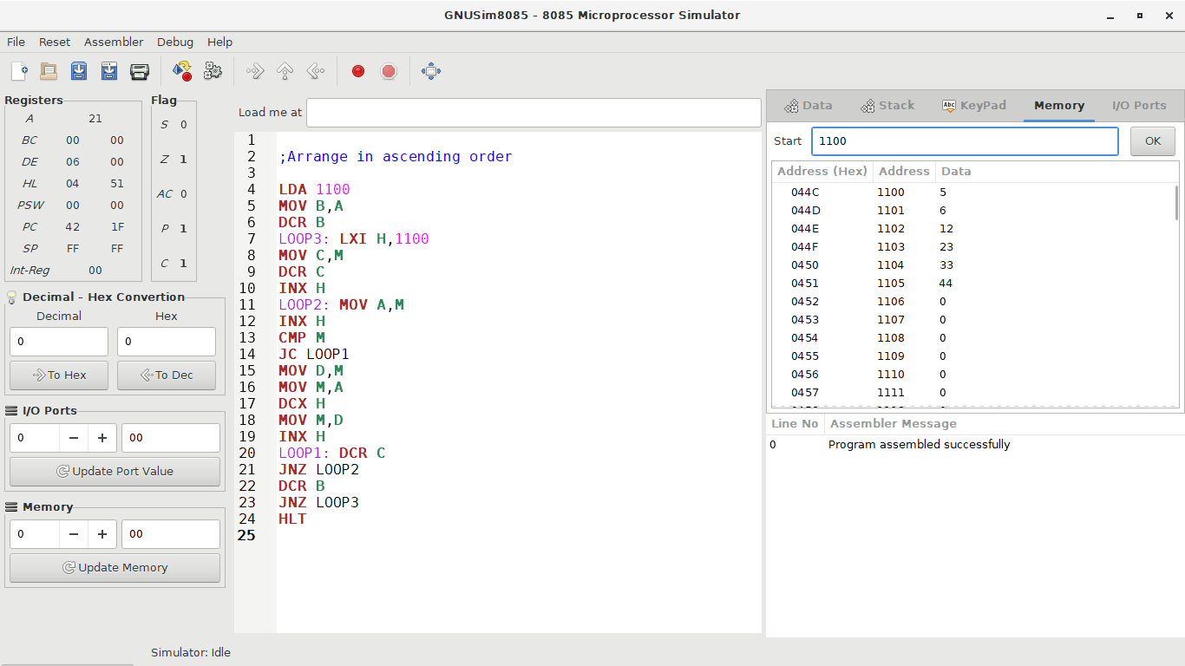

**Arrange in descending order :**

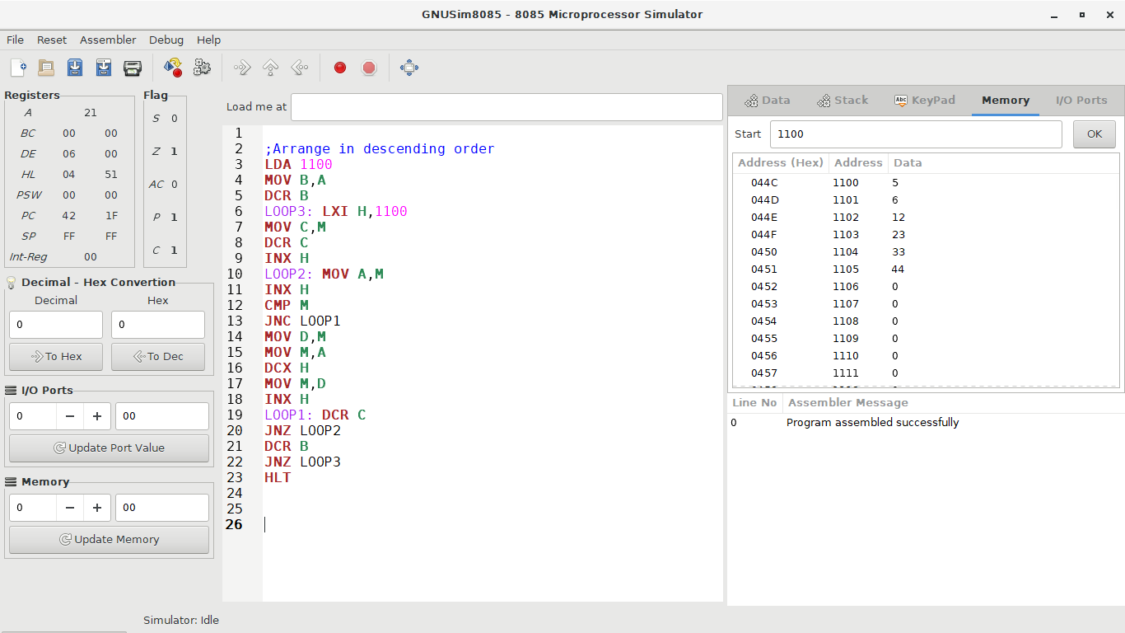

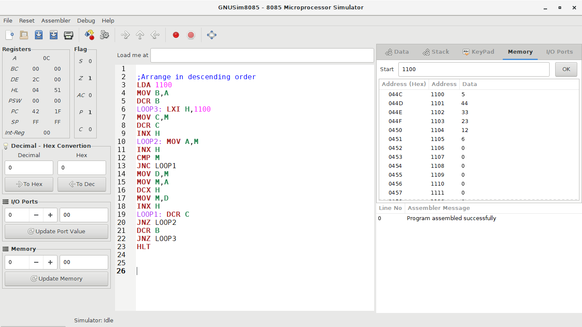

**Conclusion :** These are ways to perform ascending and descending order